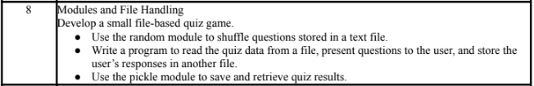
—----------------------------------------------------------------------------------------------------------------------------
COMMAND:
import random
import pickle

# Function to load questions from file
def load_questions(filename):
with open(filename, "r") as f:
lines = f.readlines()
questions = []
for line in lines:
parts = line.strip().split("|")
if len(parts) == 6:
question, op1, op2, op3, op4, correct = parts
questions.append({
"question": question,
"options": [op1, op2, op3, op4],
"answer": correct
})
return questions

# Function to save results using pickle
def save_results(results, filename="results.pkl"):
with open(filename, "wb") as f:
pickle.dump(results, f)

# Function to load results using pickle
def load_results(filename="results.pkl"):
try:
with open(filename, "rb") as f:
return pickle.load(f)
except FileNotFoundError:
return []

def quiz_game():
questions = load_questions("quiz.txt")
random.shuffle(questions) # shuffle questions

user_answers = []
score = 0

print("\n==== QUIZ GAME ====\n")

for i, q in enumerate(questions, 1):
print(f"Q{i}. {q['question']}")
for j, opt in enumerate(q["options"], 1):
print(f" {j}. {opt}")
choice = input("Enter your answer: ")
user_choice = q["options"][int(choice)-1] if choice.isdigit() and 1 <= int(choice) <= 4 else None

user_answers.append((q['question'], user_choice))

if user_choice == q["answer"]:
score += 1

print(f"\nYour Score: {score}/{len(questions)}")

# Save user responses in a file
with open("user_responses.txt", "w") as f:
for q, ans in user_answers:
f.write(f"{q} -> {ans}\n")

# Save results using pickle
results = load_results()
results.append({"score": score, "total": len(questions), "answers": user_answers})
save_results(results)

print("\n✅ Responses saved to 'user_responses.txt'")
print("✅ Results saved using pickle in 'results.pkl'")

# Run the quiz
quiz_game()

OUTPUT:
